# Noise Filter

There are different ways to remove noise in an image. Two algorithms that are very effective against impulse noise (also known as salt&pepper noise) are median filter and mean filter. We will explain how each filter works and what the advantages and disadvantages are.

## Median filter

Median filtering is a method used to remove noise from images. Median filtering is an effective method to remove impulse noise (like salt&pepper). This method works by walking through the image pixel by pixel and replacing each pixel value with the median value of neighbouring pixels. For every single pixel we place a window over the pixel we want to change. If we use a 3x3 median filter the window size will be 3 by 3 (See Figure 1).

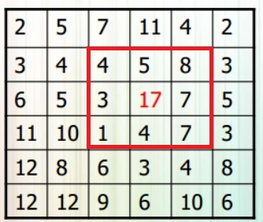

Figure 1. <https://cursussen.sharepoint.hu.nl/fnt/55/TCTI-V2VISN1-13/Studiemateriaal/Les-slides/Les%202%20-%20Neighborhood%20operations.pdf> (sheet 76)

Let’s take a look at Figure 1. As you can see in figure 1 we want to change pixel with pixel value 17 (we placed a window or neighbourhood over pixel with pixel value 17). Now we have to save all the 9 pixel values into a list and sort the list from low to high. The output will be: [1, 3, 4, 4, 5, 7, 7, 8, 17]. Because the list length is an odd number we can take the middle-ranked pixel value (as we can see in Figure 2). We now have the median value and replace pixel value 17 by pixel value 5. You will need to do this for every single pixel in your image. In this example we used a 3x3 median filter but if we used a 4x4 median filter the calculation will be a bit different. If we want to change a pixel with a 4x4 median filter the list will have a length of 16. Because there isn’t a middle-ranked pixel we will have to take the length (16 in this case) divide it by 2 (that will be 8). We now look to the value that is stored in element 8 and sum that with the next element (9) and divide that by 2. We now have the median pixel value.

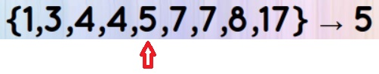

Figure .2 <https://cursussen.sharepoint.hu.nl/fnt/55/TCTI-V2VISN1-13/Studiemateriaal/Les-slides/Les%202%20-%20Neighborhood%20operations.pdf> (sheets 76)

The median filter will cost a lot of performance because for every single pixel you have to make a sorted list. There are different ways to sort a list. Quicksort will be fast, but not for small lists. If you only use a 3x3 neighbourhood Insert sort will be the fastest way to get the job done. The smartest way to find the median value, you can make a histogram of the neighbourhood. Figure 3 shows execution times for median filter of a 515x512 image. Another problem is that edges won’t be changed because we can’t place a window over the edge pixels (See Figure 4).

Advantages:

* It is very simple to understand
* Reduces noise
* The median filter will cause minimal blurring
* If there is an unusual pixel value in the neighbourhood, it won’t have effect on the median pixel value

Disadvantages:

* Less effective in removing other noise then impulse noise
* As we told earlier, it cost a lot of performance
* Reduces detail

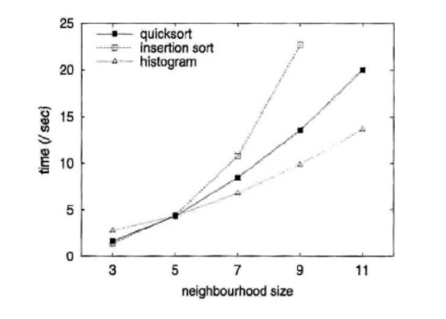

Figure 3. <https://cursussen.sharepoint.hu.nl/fnt/55/TCTI-V2VISN1-13/Studiemateriaal/Extra%20Literatuur/Neighbourhood%20operations.pdf> (p.180)

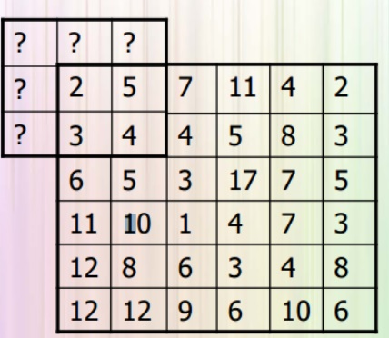

Figure 4. <https://cursussen.sharepoint.hu.nl/fnt/55/TCTI-V2VISN1-13/Studiemateriaal/Les-slides/Les%202%20-%20Neighborhood%20operations.pdf> (sheet 23)

## Mean filter

The mean filter has many similarities with the median filter. Just like median filtering the mean filter is an effective way to remove impulse noise (for example salt&pepper). This method works by walking through the image pixel by pixel and replacing each pixel value with the median value of neighbouring pixels. For every single pixel we place a window over the pixel we want to change. If we use a 3x3 median filter the window size will be 3 by 3 (See Figure 5).

Figure 5. <https://cursussen.sharepoint.hu.nl/fnt/55/TCTI-V2VISN1-13/Studiemateriaal/Les-slides/Les%202%20-%20Neighborhood%20operations.pdf> (sheet 76)

Let’s take a look at Figure 5. As you can see in figure 1 we want to change pixel with pixel value 17 (we placed a window or neighbourhood over pixel with pixel value 17). Now we have to save all the 9 pixel values into a list. The list will contain the following numbers: [4, 5, 8, 3, 17, 7, 1, 4, 7]. For getting the mean pixel value we have sum all the elements and divide the sum by the number of elements (9 in this case). In this case the sum is 56 and if we divide it by 9 we will get 6,2222. Because the value is an integer the mean pixel value will be round to 6. We now have the mean value and replace pixel value 17 by pixel value 6. You will need to do this for every single pixel in your image.

A problem is that edges won’t be changed because we can’t place a window over the edge pixels (See Figure 4).

Advantages:

* It is very simple to understand
* Reduces noise
* Faster then median filter because you didn’t have to sort the list for each pixel

Disadvantages:

* Less effective in removing other noise then impulse noise
* If there is an unusual pixel value in the neighbourhood, it will have effect of the mean filter value
* Reduces detail